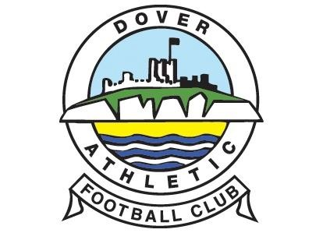

To the Parents/ Guardians / Carers of:
Name of Child: ……………………………………………………………………………………………….

Occasionally, we may take photographs of the children during activities. We may use these images on children’s club promotional material or on our website. We may also make video recordings for promotional material, monitoring or other educational uses.

From time to time, our club may be visited by the media who will take photographs or film footage of a visiting dignitary or other high profile event. The children will often appear in these images, which may appear in local or national newspapers, or on televised news programmes.

To comply with the Data Protection Act 1998, we need your permission before we can photograph or make any recordings of your child. Please answer questions 1 to 4 below, then sign and date the form where shown.

PLEASE RETURN THE COMPLETED FORM TO THE SCHOOL AS SOON AS POSSIBLE.

Please circle your answer
- May we use your child’s images (unidentified) on our website? | Yes / No
- May we use your child’s photograph (unidentified) in any printed publications that we produce for promotional purposes? | Yes / No
- May we record your child’s image (unidentified) on video? | Yes / No
- Do you consent to your child being photographed or filmed in press events agreed by the club? | Yes / No
- Do you consent to photos and videos being kept at the club? | Yes / No

Please note that websites can be viewed throughout the world and not just in the United Kingdom where UK law applies.

Unidentified means we will only use the first name
Please also note the conditions for use of these photographs are on the back of this form.

Declaration:
I have read and understood the conditions of use on the back of this form.

Parent’s or Guardian’s signature ………………………………………….Date…………………………..

Name (in BLOCK CAPITALS) ………………………………………………………………………………………………...

CONDITIONS OF USE

- This form is valid for five years from the date you sign it. The consent will automatically expire after this time. It is your responsibility to let us know if you want to withdraw or change your agreement at any time.
- We, the club, will not use the personal details or full names (which means first name and surname) of any child in a photographic image on video, on our website, or in any of our other printed publications.
- We will not include personal e-mail or postal addresses, or telephone or fax numbers on video, on our website, or in other printed publications.
- If we use photographs of individual children, we will not use the name of the child in the accompanying text or photo caption, unless we have your agreement.
- If we name a child in the text, we will not use a photograph of that child to accompany the article.
- We may use group photographs or footage with very general labels, such as “half term club” or “free kick practise”.
- We will only use images of children who are suitably dressed, to reduce the risk of such images being used inappropriately.
- As the child’s parents/guardian/carer, you agree that if you take photographs or video recordings of your child which include other children, you will use these for personal and family use only. You understand that where consent has not been obtained from the other parents for any other use, you would be in breach of the Data Protection Act 1998 if you used your recordings for any wider purpose.

