Dover Athletic Academy in partnership with The Abbey School
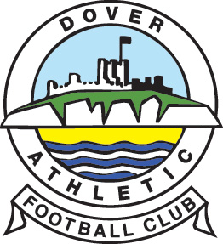

Dear Player,

I am pleased to invite you to Dover Athletic Football Academy’s initial trials for the 2020-21 intake. As you are most probably aware, the Academy gives our students the opportunity to represent Dover Athletic FC in the National Youth league, the highest level outside of professional status.

The Academy players train everyday like professionals, improving their knowledge of the game and allowing a seamless progression into senior football. The players also study a wide range of courses in our Sixth Form tailored to suit their academic needs and career aspirations.

The Academy has been very successful over the past couple of years resulting in players being given professional contracts by Dover Athletic. In the last few years we have also progressed players onto scholarships in America. In the 2018/19 Season the Academy was also crowned Champions of Champions and recognised as the best Academy in the country. We are also extremely proud of Academy Graduate Sean Raggett who is now a Professional Footballer for Norwich City in the Premier League.

What do you need to know?

Taking place on Monday 17th February (during half term).
Registration at 10.30am for an 11.00am start.
Finish approximately 2.00pm.
Bring full training kit including shin pads.
It will be outside on our 3G pitch (suitable for football boots).
Trials will consist of a variety of matches.
There will be shower and changing room facilities available for you to use.
Trials will be held at The Abbey School, London Road, Faversham, ME13 8RZ.
Parents/Carers are welcome to stay and watch.

Following the trial, you will receive a letter in the post informing you of the outcome. If you are successful but cannot make the first alternative trial date, then alternative arrangements can be made to accommodate this situation.

As this opportunity is in partnership with The Abbey School, if successful you would be expected to take up your Sixth Form studies at the school.

In order to confirm your attendance at the trial you must return the slip below to Mr M Sandmann, The Abbey School, London Road, Faversham, ME13 8RZ.

Yours sincerely

Mr M Sandmann Mr R Clarke
msandmann@abbeyschoolfaversham.co.uk rclarke@abbeyschoolfaversham.co.uk Football Academy Manager Assistant Head of KS5

To: Mr Sandmann and Mr Clarke

I am pleased to confirm that _______________________ ____________will be attending the trials.

Date of birth: __________________ Age: ________Contact Number________________________

Parent/Carer name: ________________________

Address: ________________________________________________________________________

________________________________________________________________________

Playing clubs: ____________________________________________________________________

Preferred position: _________________________ School: ________________________________

